Work Study Profile
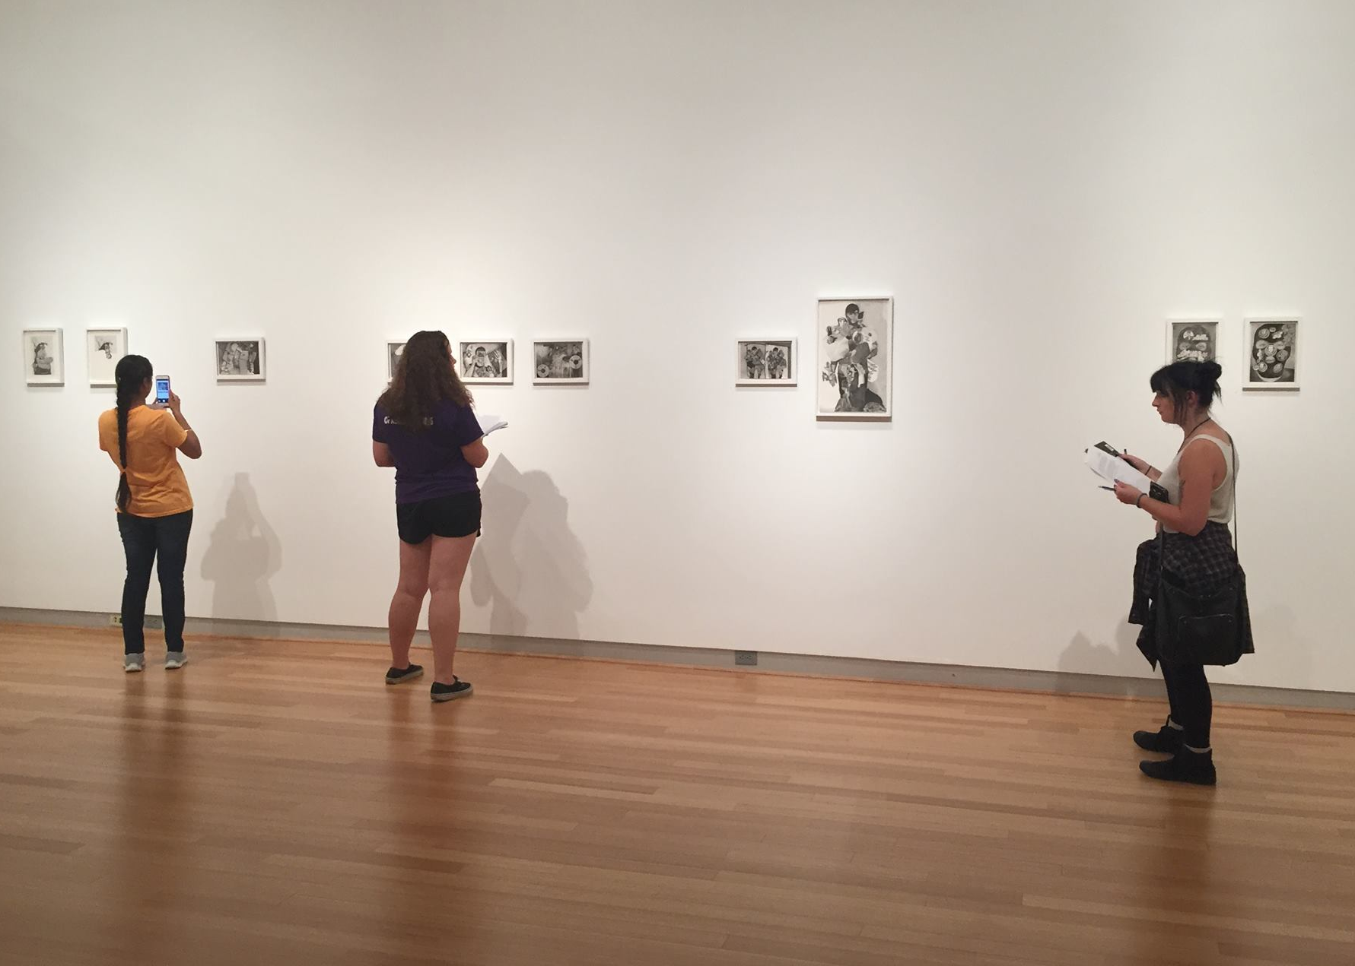
  - Federal Work Study (FWS) provides an opportunity for part-time employment for undergraduate and graduate students with financial need. The program allows students to earn money to help pay education related expenses. In the 2016-17 academic year, 481 students participated in the work study program. Of those students 403 were undergraduates whose average work study award was $3,146.25. At the graduate/professional level there were 78 students who participated with an average award was $3,075.77.

2016-17
 | Undergraduate |  | Graduate/Professional
 | N | % of Total | N | % of Total
Total | 403 | 83.8% | 78 | 16.2%
Avg. Work Study Offered | $2,802.25 |  | $2,844.92
Avg. Work Study Awarded | $3,146.25 |  | $3,075.77

What does a typical work study student look like?
At the undergraduate level, 35.2% students in the work study program were seniors and the remaining were evenly spaced out between the other levels. There were 294 females (73.0%) and the highest minority group was African Americans at 21.6%. Thirty-nine percent were first generation students and 24.6% of the undergraduate students were beginners. Of the undergraduate population, 33% were between 20-21 years of age. Undergraduates 25 and older were the least likely to receive work study at 9.9%. Approximately 26% of undergraduate work study students lived in campus housing.

The student characteristics of graduate/professional level work study students were similar to the undergraduate level in that 75.6% were female, the highest minority group was African Americans at 5.1%, 24.4% were first generation students, and 20.5% were beginners. However, 51.3% of graduate students receiving work study were 25 or older.

How do the work study students preform?
Academically, 88.1% of the undergraduates were full-time in the Fall of 2016. Of those, 40.2% were taking 15 or credit hours or more. The average Full-Time course load for undergraduates was 15.6 hours. For all undergraduate work study students the average cumulative credit hours earned was 86.2. The average GPA was 3.03 with only 2.0% earning a GPA less than 2.00.

For full-time beginning work study students the average cumulative credit hours earned was 37.3. The average GPA was 2.89 with 12.2% earning a GPA less than 2.00.

For full-time new external transfer work study students the average cumulative credit hours earned was 84.2. The average GPA was 2.70 with 20.8% earning a GPA less than 2.00.

What was the outcome of the work study students?
For the full-time beginning bachelor’s seeking students the retention rate was 80.6%. The 2012 four year graduation rate was 30.7% and the 2010 six year graduation rate was 46.8%.

For the full-time new external transfer bachelor’s seeking students the retention rate was 85.7%. The 2012 four year graduation rate was 60.0% and the 2010 six year graduation rate was 75.0%.

What type of financial aid did they receive?
In terms of financial aid, 85.2% of undergraduate work study students received a Pell Grant, 23.8% received 21st Century Scholar funds and 38% received an O’Bannon grant.

What programs were the work study students who were beginners involved?
Of the fall 2016 beginners who participated in work study, 68.4% lived in campus housing, 30.6% were the Summer Bridge program, 14.6% were in a Themed Learning Community (TLC) and 16.3% were in the Diversity Enrichment and Achievement Program (DEAP). For additional information see the charts below.

Historically, how many students participated in work study?

Demographics
 | N |  | % of Level
Student Level
Freshman | 85 |  | 21.1%
Sophomore | 84 |  | 20.8%
Junior | 92 |  | 22.8%
Senior | 142 |  | 35.2%
Graduate | 42 |  | 53.8%
Professional | 36 |  | 46.2%
 | N |  | % of Undergrad |  | N |  | % of Grad/Prof
Gender
Female | 294 |  | 73.0% |  | 59 |  | 75.6%
Male | 109 |  | 27.0% |  | 19 |  | 24.4%
Race/Ethnicity
African American | 87 |  | 21.6% |  | 4 |  | 5.1%
American Indian | - |  | - |  | - |  | -
Asian American | 28 |  | 6.9% |  | - |  | -
Hispanic/Latino | 55 |  | 13.6% |  | 1 |  | 1.3%
International | - |  | - |  | - |  | -
Native Hawaiian | 1 |  | 0.2% |  | - |  | -
Two or More Races | 21 |  | 5.2% |  | 1 |  | 1.3%
Unknown | 3 |  | 0.7% |  | - |  | -
White | 208 |  | 51.6% |  | 72 |  | 92.3%
First Generation
First Generation | 157 |  | 39.0% |  | 19 |  | 24.4%
Student Status
Beginners | 99 |  | 24.6% |  | 16 |  | 20.5%
Transfers | 30 |  | 7.4% |  | - |  | -
Age
<20 | 117 |  | 29.0% |  | - |  | -
20-21 | 133 |  | 33.0% |  | - |  | -
22-24 | 113 |  | 28.0% |  | 38 |  | 48.7%
25+ | 40 |  | 9.9% |  | 40 |  | 51.3%
Campus Housing
Campus Housing | 107 |  | 26.6% |  | - |  | -
Academics
 |  | Fall* |  |  |  | Spring**
 |  | N |  | % |  | N |  | %
Undergraduate
Full-time |  | 349 |  | 88.1% |  | 318 |  | 83.0%
15 or More Hours |  | 159 |  | 40.2% |  | 153 |  | 48.1%
Average FT Hours |  | 15.6 |  | - |  | 15.6 |  | -
Graduate/Professional
Full-time |  | 72 |  | 92.3% |  | 68 |  | 87.2%
Average FT Hours |  | 15.0 |  | - |  | 13.2 |  | -
*Of the 403 undergraduates with work study 7 students were not enrolled in the fall and Of the 78 grad/prof students with work study 1 student was not enrolled in the fall.
**Of the 403 undergraduates with work study 20 students were not enrolled in the spring and Of the 78 grad/prof students with work study 1 student was not enrolled in the spring.

Outcomes
 | Undergraduate |  | Graduate
 | N | % of Undergrad | N | % of Grad/Prof
Credit Hours Earned | 86.2 |  | 60.7
Average GPA | 3.03 |  | 3.80
GPA < 2.0 | 24 | 6.0% | 0 | 0.0%
Full-time | 2016 Fall Beginners |  | 2016 New External Transfers
 | N | % | N | %
Credit Hours Earned | 37.3 |  |  | 84.2
Average GPA | 2.89 |  |  | 2.7
GPA < 2.0 | 12 | 12.2% | 5 | 20.8%
 | Beginners  1 Year Retention* | Transfer  1 Year Retention*
Retention | 80.6% | 85.7%
*Full time bachelor’s degree seeking.
 | Beginners |  | Transfers
 | 4Yr* | 6Yr** | 4Yr* | 6Yr**
Graduation Rates | 30.7% | 46.8% | 60.0% | 75.0%
*Four year rates are based on 2012 full time bachelor’s seeking receiving bachelor’s degree.
** Six year rates are based on 2010 full time bachelor’s seeking receiving bachelor’s degree.

Financial Aid - Undergraduates
 | N | % of Undergrad
Pell | 344 | 85.4%
21st Century Scholar* | 96 | 23.8%
O’Bannon | 153 | 38.0%
*Receiving 21st Century Scholar funds

Beginners*
 | N | % of Beginners*
Campus Housing | 67 | 68.4%
Summer Bridge | 30 | 30.6%
TLC | 14 | 14.6%
First-Year Seminars | 98 | 100.0%
DEAP | 16 | 16.3%
*Fall 2016 Beginners

